Reactio Draw — test of the compound marks
A test of compound numbering in Word with Reactio Draw (Windows or Mac, the Reactio Draw tab installed). On the Reactio Draw tab: Number compounds (Style {n}, From 1). Then Show marks, Number compounds again, Remove marks, Final copy. The notes in italics have no marks and stay as they are; the drawings are Reactio Draw drawings (double-click one to edit it).
Expected after Number compounds: chapter 1 — aldehyde 1, aniline 2, amine 3 and the scope 3a–3d, catalysts A and B, 1.1 and 1.2 with a point, 2-1 and 2-2 with a dash, a/b and i/ii, the cycle I–IV, by-product 4, the slip 5; chapter 2 — 2-1 and 2-2, aldehyde 1 and catalyst A as before; chapter 3 — S5 and S6, amine 3 as before.
Chapter 1
Drawing 1: a reaction; the catalyst over the arrow is a series of its own (A).
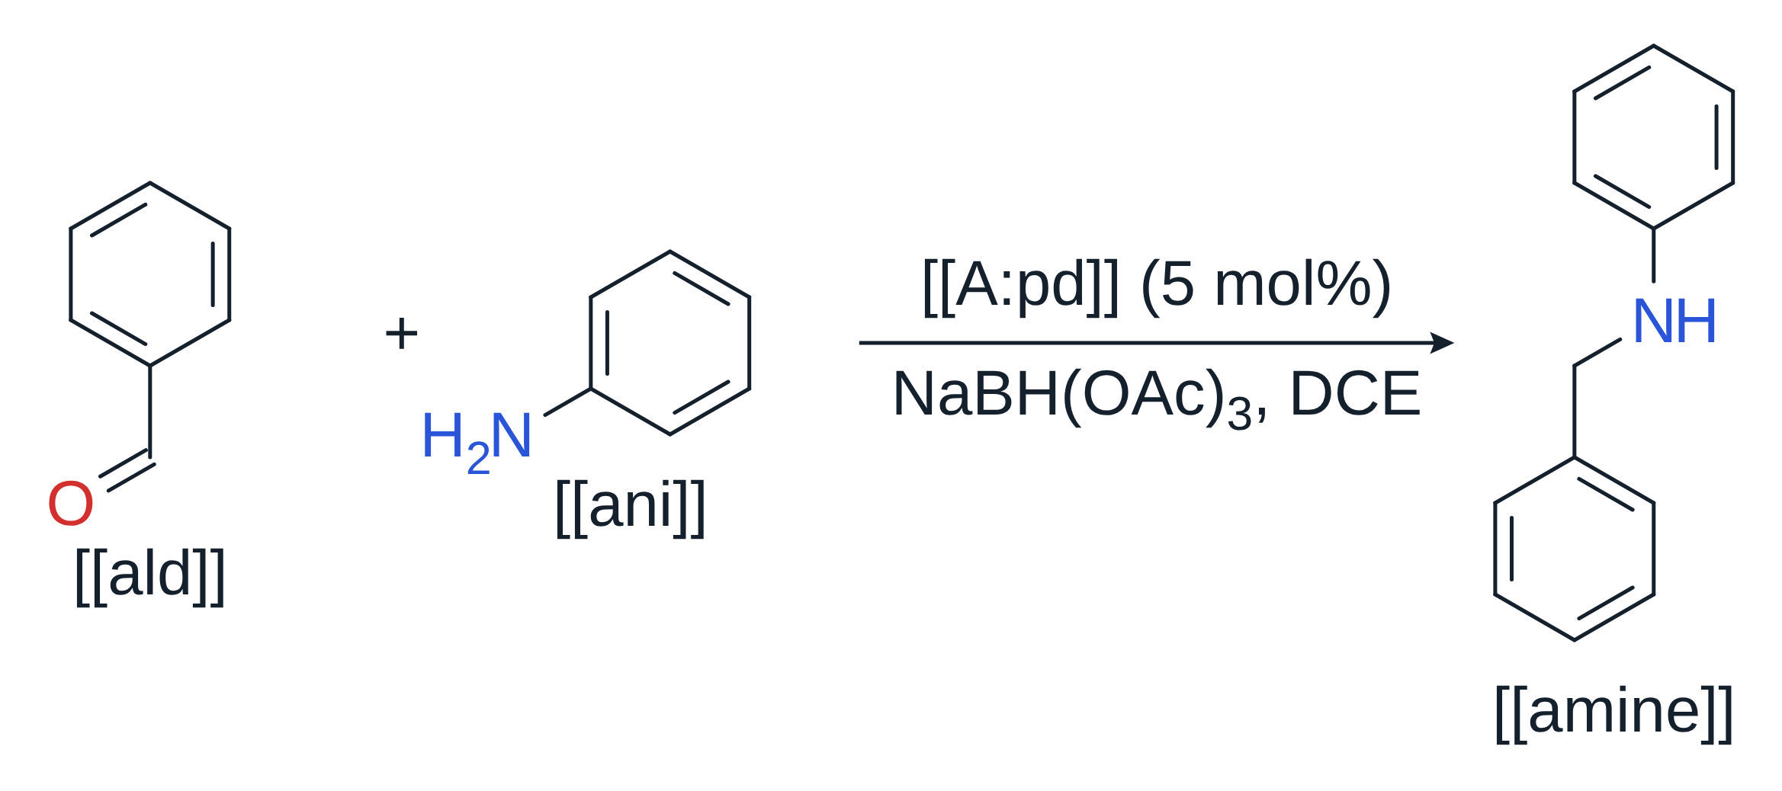
Aldehyde [[ald]] and aniline [[ani]] gave amine [[amine]] with catalyst [[A:pd]] (5 mol%); catalyst [[A:ni]] gave no product.
Drawing 2: the substrate scope, marks as the Compound numbers panel writes them from the template amine.{n}.letter, with yields.
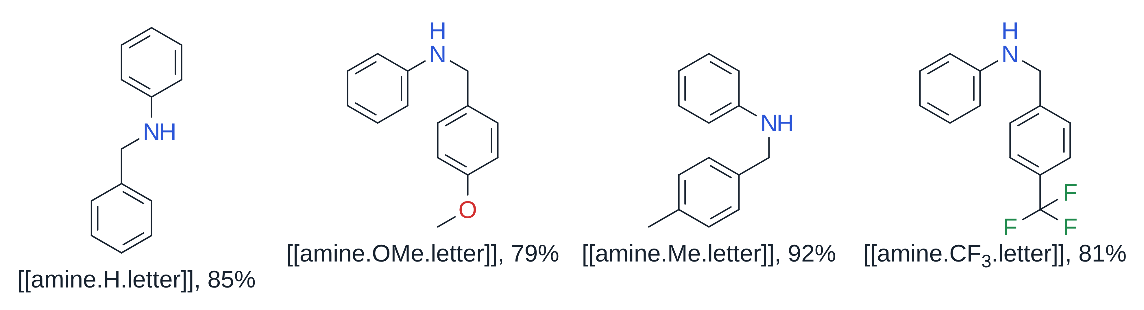
Amines [[amine.H.letter]]–[[amine.CF3.letter]] were obtained in 79–92% yield; [[amine.OMe.letter]] needed 24 h.
Numbered with a point: aldehydes [[ald.OMe.num]] and [[ald.Cl.num]]. Numbered with a dash: anilines [[ani.Br.dash]] and [[ani.I.dash]]. A short form of a letter mark: [[ald.F]].
Conditions [[a:dry]] and [[a:wet]] (small letters); transition states [[i:ts1]] and [[i:ts2]] (small Roman numerals).
Drawing 3: a catalytic cycle; its order is set by hand round the cycle (Ctrl+Shift+O), so I–IV go clockwise from the top, not in reading order.
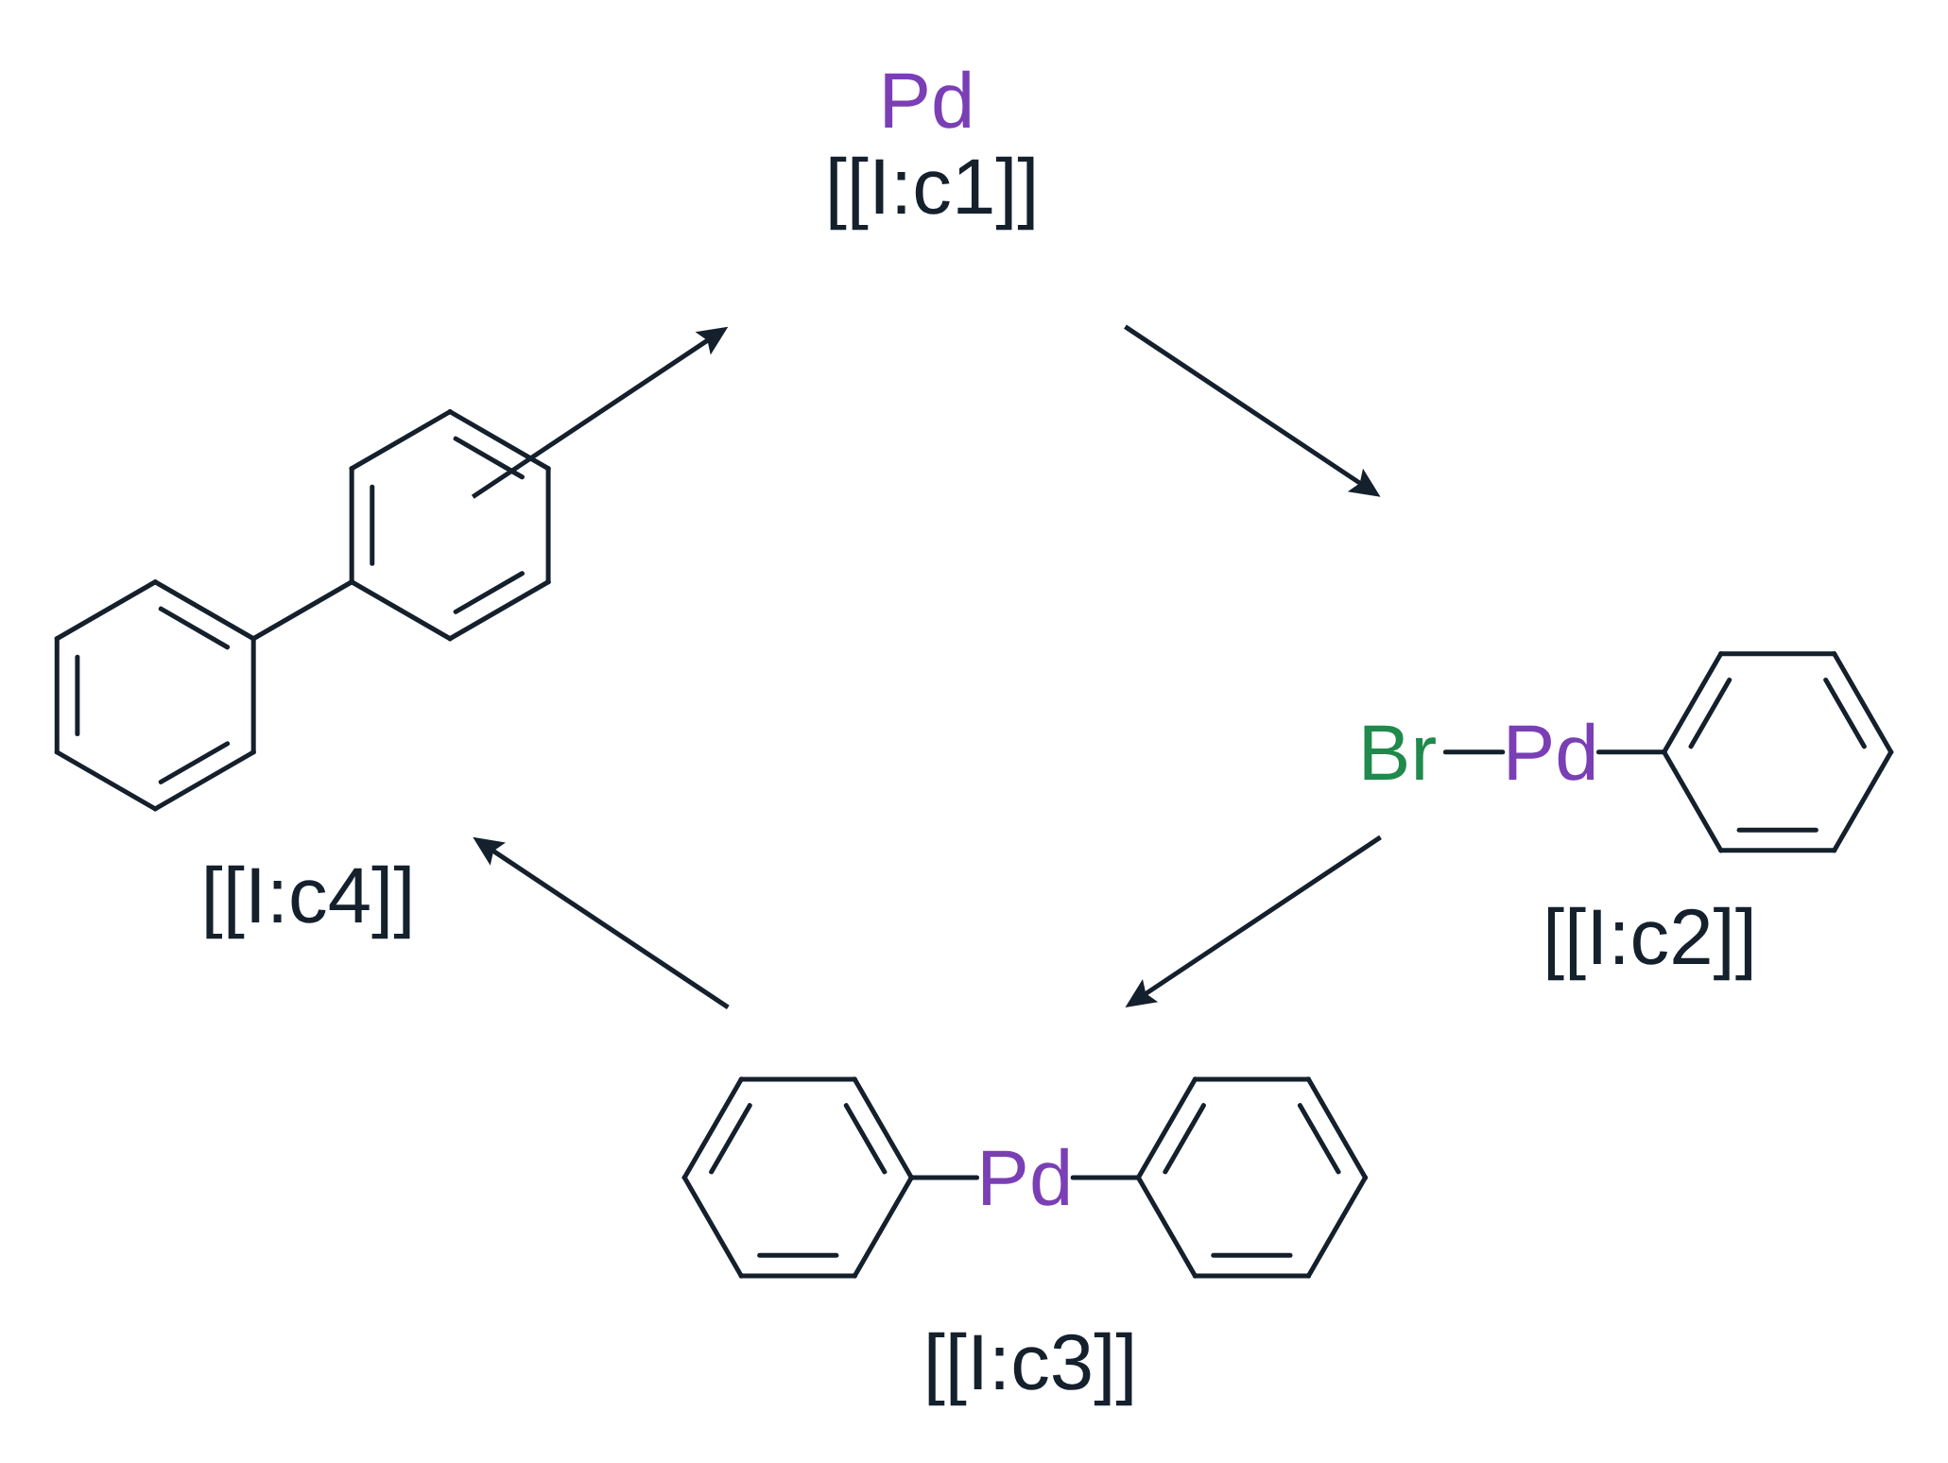
The cycle runs through intermediates [[I:c1]], [[I:c2]], [[I:c3]] and [[I:c4]].
By-product [[byp]] is only in the text: it is numbered after the compounds of the drawings; [[byp]] was removed by chromatography.
A key met only once, [[amin]], is named in the message as a possible typing slip.
Chapter 2
The next line sets this chapter's style. After Number compounds it is hidden text: it does not print and leaves no empty line. If you still see it, with a dotted underline, Word is showing hidden text: ¶ (Ctrl+Shift+8) is on, or File → Options → Display → Hidden text is ticked. Show marks shows it as plain text, to read or change it.
[[#format 2-{n}]]
Drawing 4: chapter 2 has its own drawings first.
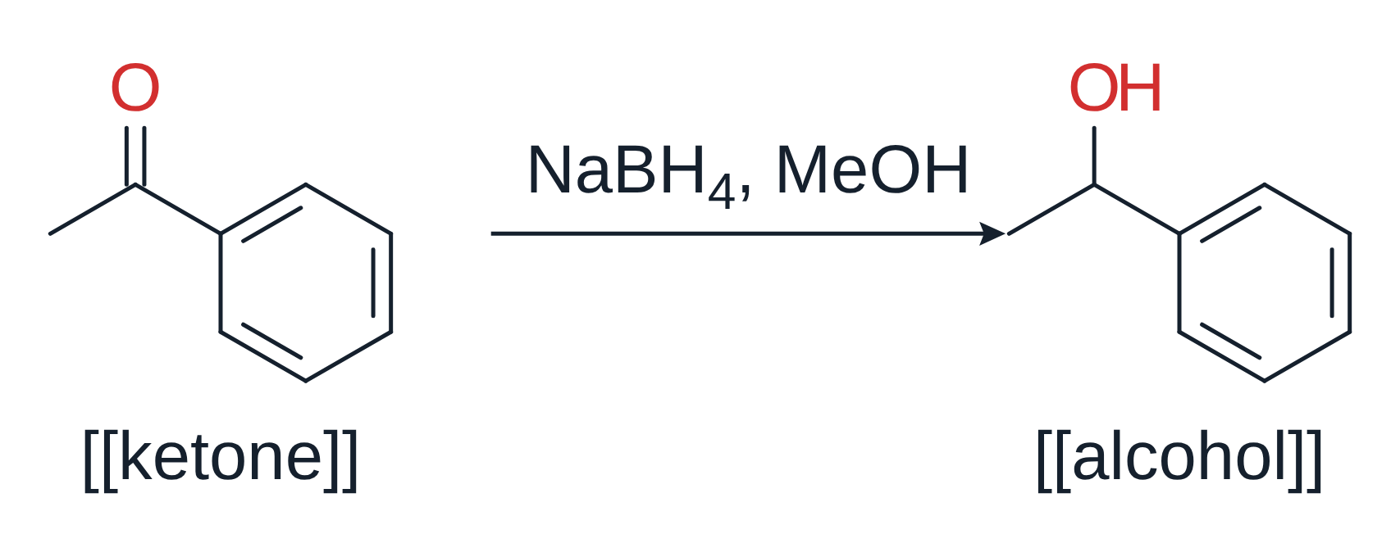
Ketone [[ketone]] was reduced to alcohol [[alcohol]]. Aldehyde [[ald]] from chapter 1 keeps its number, as does catalyst [[A:pd]].
Chapter 3 (Supporting Information)
Two settings on one line: style S{n}, starting from 5 (hidden after numbering, as in chapter 2).
[[#format S{n}]] [[#start 5]]
New compounds [[si1]] and [[si2]]; amine [[amine]] keeps its number. Characterization data for [[si1]] and [[si2]] follow.

